Project 25 bugs

By Fredrick Östlund



**Level design: exit game gate**

In the end area of the game at a high enemy portal it’s possible to build a pile of junk and climb it and then the player can jump over this gate and exit the game stage. It is not possible to go back or end the game when this is done. The player can walk around in midair in it.

1. Build a pile of junk. Use the junk car as a foundation by moving it from the upper street with the gravity gun, and then build on it with the two shelves. One can also use the boxes in earlier levels. This takes a while to complete.

2. Climb the pile.

3. Try jumping over the gap between the gate and the valve. This also demands some patience.

4. When done, the player is stuck behind the gate and the game has to be restarted.

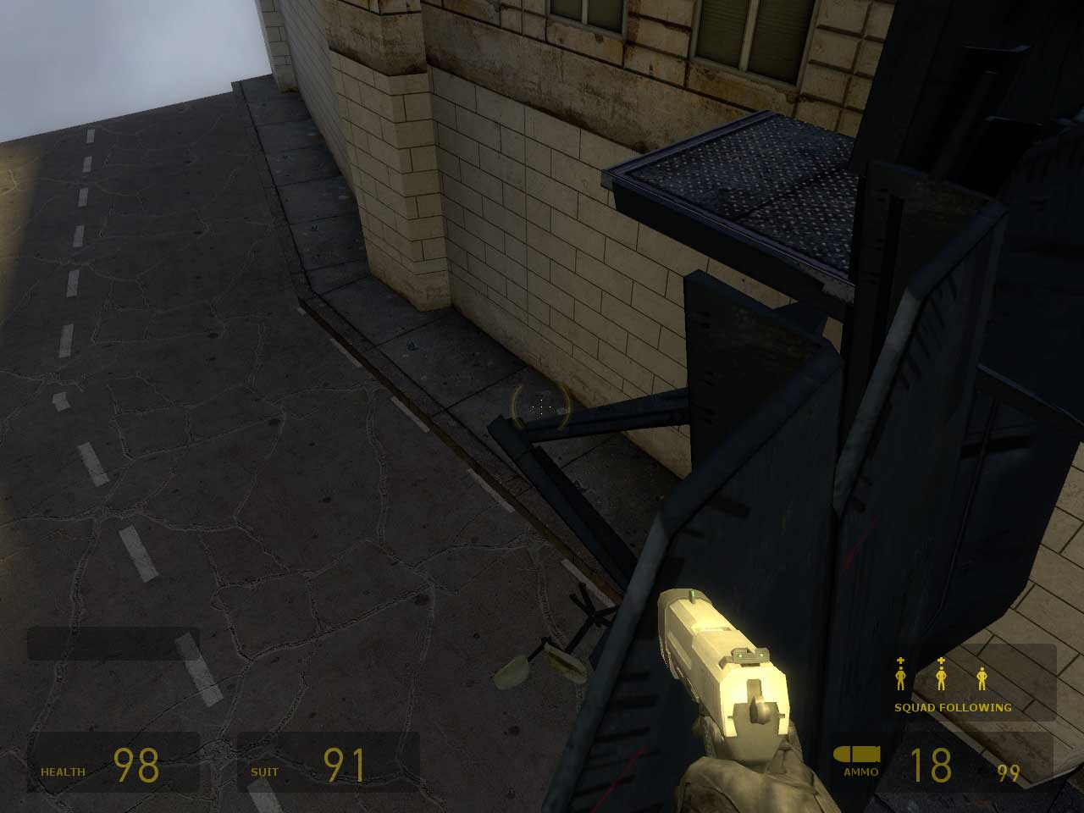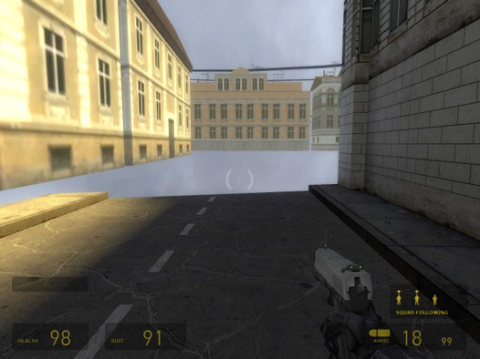

**Bug2.**

**Level design: start the set piece in the wrong way**

Getting through the pretty low portal at the end of the game that can be opened with the batteries can also be accomplished by climbing a box or other game items, without gathering the batteries to solve the puzzle. This could possibly be a game feature, but seems more of a design glitch.

1. Don’t collect the batteries

2. Gather a box of some sort or other game item.

3. Climb it.

4. Try to jump over the door, and an invisible gate will stop the player and the set piece will start.

**Bug3.**

Modeler: fire thru the wall

One of the fires at the end level can be seen through a concrete wall.

1. In the end area, to the left of the “battery gate” approx. 10 m there is a fire behind the ruin wall.

2. Look from the side of the wall.

3. The fire can sometimes be seen through the wall.

**Bug4.**

Code: Door without collision detection

At the level with zombies locked behind a force field there is a door. This door can be opened by attaching a cord to two sockets. If the player has brought a barrel and touches it to the door, the door doesn’t have any collision detection and the barrel can be pushed through it.

1. Bring a barrel using the gravity gun to the area with the locked away zombies.

2. Use the cord to open the door.

3. Use the gravity gun and walk to the door, push the barrel towards it.

4. The barrel can easily pass through the door.

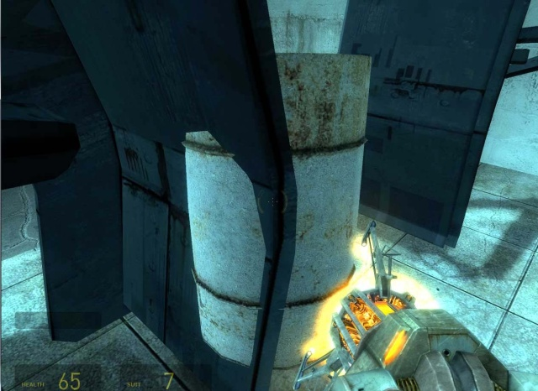

**Bug5.**

Gameplay: door moves the player

After the first level with the acid filled floor there are some NPCs in the next room. After defeat the player can enter the small fenced in storage area (and collect stuff, if wanted). If the player stands too much to the left when opening this door (it goes outwards) the door pushes the player backward. Nothing implies that the door can open by itself (use its own force like an engine etc.) so it is probably the player itself that opens it. But it is impossible to move one’s self. Maybe it would be better if the player took a step back or something (an animation could have shown this)? This could be seen as a game feature but moving doors are always a problem in games.

1. Enter the area and kill the zombies.

2. Go to the fenced door.

3. Stand to the left, and open the door.

4. Most of the times the door “moves” the player.